**Lab#5 Using PHP OOP, implement following using design of lab 3:**

**a. Create a database for mobile shopping.**

**Final Outcome:**

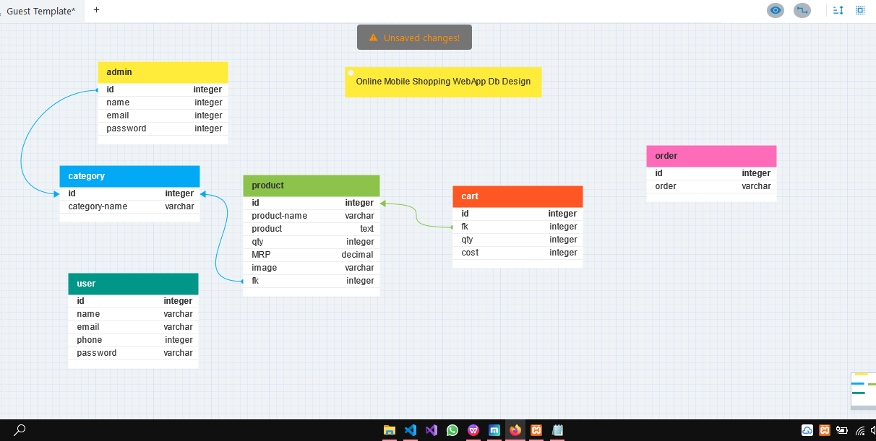

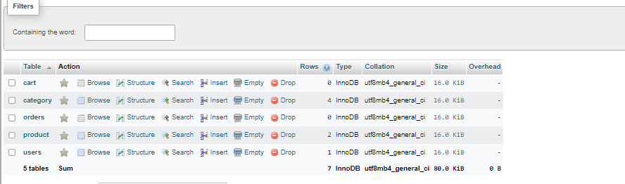

**b. Implement registration page and login system with session management**

**Code snippet:**

**Registration.php**

<!DOCTYPE html>

<html lang="en">

<head>

<title>Bootstrap Example</title>

<meta charset="utf-8">

<meta name="viewport" content="width=device-width, initial-scale=1">

<link href="https://cdn.jsdelivr.net/npm/bootstrap@5.2.3/dist/css/bootstrap.min.css" rel="stylesheet">

<script src="https://cdn.jsdelivr.net/npm/bootstrap@5.2.3/dist/js/bootstrap.bundle.min.js"></script>

<link rel="stylesheet" href="https://cdnjs.cloudflare.com/ajax/libs/font-awesome/6.3.0/css/all.min.css">

<style>

.form-box-signup{

background-color: #333;

border-radius: 20px;

width: 40%;

position: absolute;

top:50%;

left:50%;

transform: translate(-50%,-50%);

}

.user button i {

color: #fff;

border-radius: 50%;

}

.card-body a {

text-decoration: none;

color: #0aff37;

}

.login-media #loginlink,

#cartlink {

color: #fff;

display: none;

}

.user button {

border: 2px solid #fff;

transform: scale(1.13);

margin-left: 15px;

border-radius: 50%;

background-color: transparent;

}

.cart i {

color: #fff;

border: 2px solid #fff;

margin-left: 10px;

padding: 7px;

border-radius: 50%;

}

.slider img {

height: 70%;

width: 100%;

}

.row img {

margin-top: 10px;

margin-left: 70px;

height: 47%;

width: 65%;

}

.star {

background-color: rgb(34, 0, 128);

color: #fff;

padding: 0px 4px 0 4px;

border-radius: 4px;

}

.sell {

margin-left: 15px;

transform: translateY(-2px);

display: inline-block;

}

.office-cat {

margin-top: 25px;

}

.error{

color: red;

position: absolute;

}

</style>

</head>

<body class=" bg-opacity-50 bg-primary ">

<?php

session_start();

#define empty variable;

$name_err=$mob_err=$email_err=$pass_err=$cpass_err=$dob_err="";

if($_SERVER["REQUEST_METHOD"]=="POST")

{

//NAME VALIDATION

if(empty($_POST['name']))

{

$name_err="Enter Name";

}

else if(!preg_match("/^[a-zA-Z]*$/",$_POST['name']))

{

$name_err="only letters and white space allowed";

}

//MOBILE NUMBER VALIDATION

if(empty($_POST['phone']))

{

$mob_err="enter mobile number";

}

else if(!preg_match("/^[0-9]{10}$/",$_POST['phone']))

{

$mob_err="Enter valid phone number";

}

//EMAIL VALIDATION

if(empty($_POST['email']))

{

$email_err="enter email";

}

else if(!filter_var($_POST['email'],FILTER_VALIDATE_EMAIL))

{

$email_err="Enter Valid email";

}

//PASSWORD VALIDATION

if(empty($_POST['pswd']))

{

$pass_err="enter password";

}

else if(strlen($_POST['pswd']<8))

{

$pass_err="password must be atleast 8 characters";

}

//CONFIRM PASSWORD ERR

if(empty($_POST['cpswd']))

{

$cpass_err="Enter Confirm password";

}

else if($_POST['pswd']!=$_POST['cpswd'])

{

$cpass_err="password and confirm password not match";

}

if(empty($name_err)&&empty($mob_err)&&empty($email_err)&&empty($pass_err)&&empty($cpass_err))

{

$_SESSION['uname']=$_POST['name'];

$_SESSION['email']=$_POST['email'];

$_SESSION['password']=$_POST['pswd'];

header("location:home.php");

}

}

?>

<!--navbar start-->

<nav class="navbar navbar-expand-lg navbar-dark bg-dark text-white">

<div class="container-fluid">

<a class="navbar-brand" href="#">Shopizy&nbsp;<i class="fa-sharp fa-solid fa-cart-plus"></i></a>

<button class="navbar-toggler" type="button" data-bs-toggle="collapse" data-bs-target="#navbarScroll" aria-controls="navbarScroll" aria-expanded="false" aria-label="Toggle navigation">

<span class="navbar-toggler-icon"></span>

</button>

<div class="collapse navbar-collapse" id="navbarScroll">

<ul class="navbar-nav me-auto my-2 my-lg-0 navbar-nav-scroll" style="--bs-scroll-height: 100px;">

<li class="nav-item">

<a class="nav-link active" aria-current="page" href="#">Home</a>

</li>

<li class="nav-item">

<a class="nav-link" aria-current="page" href="featured.html">Featured</a>

</li>

<li class="nav-item">

<a class="nav-link " area-curren="page" href="about.html">About Us</a>

</li>

<li class="nav-item">

<a class="nav-link " area-curren="page" href="contact.html">Contact Us</a>

</li>

</ul>

</div>

</div>

</nav>

<!--navbar over-->

<!--Form starts here-->

<div class="form-box-signup mt-4" id="demo" >

<div class="container mt-4 text-white">

<h2 class="text-center">Sign Up</h2>

<form action="" method="post" onsubmit="return handleSubmit()">

<div class="mb-3 mt-1 mx-4">

<label for="email">Name:</label>

<input type="text" class="form-control" id="name" placeholder="Enter Name" name="name">

<span class="error"> <?php echo $name_err;?> </span>

</div>

<div class="mb-3 mt-3 mx-4">

<label for="phone">Phone Number:</label>

<input type="text" class="form-control" id="phnum" placeholder="Enter Phone numbre" name="phone">

<span class="error"> <?php echo $mob_err;?> </span>

</div>

<div class="mb-3 mt-3 mx-4">

<label for="email">Email:</label>

<input type="email" class="form-control" id="email" placeholder="Enter Email" name="email">

<span class="error"> <?php echo $email_err;?> </span>

</div>

<div class="mb-3 mx-4">

<label for="pwd">Password:</label>

<input type="password" class="form-control" id="pwd" placeholder="Enter password" name="pswd">

<span class="error"> <?php echo $pass_err;?> </span>

</div>

<div class="mb-3 mx-4">

<label for="pwd">Confirm Password:</label>

<input type="password" class="form-control" id="cpwd" placeholder="Enter confirm password" name="cpswd">

<span class="error"> <?php echo $cpass_err;?> </span>

</div>

<div class="row mb-4 mx-4 mt-2">

<input type="submit" class="btn btn-primary" value="submit">

</div>

</form>

</div>

</div>

</body>

</html>**Outcome:**

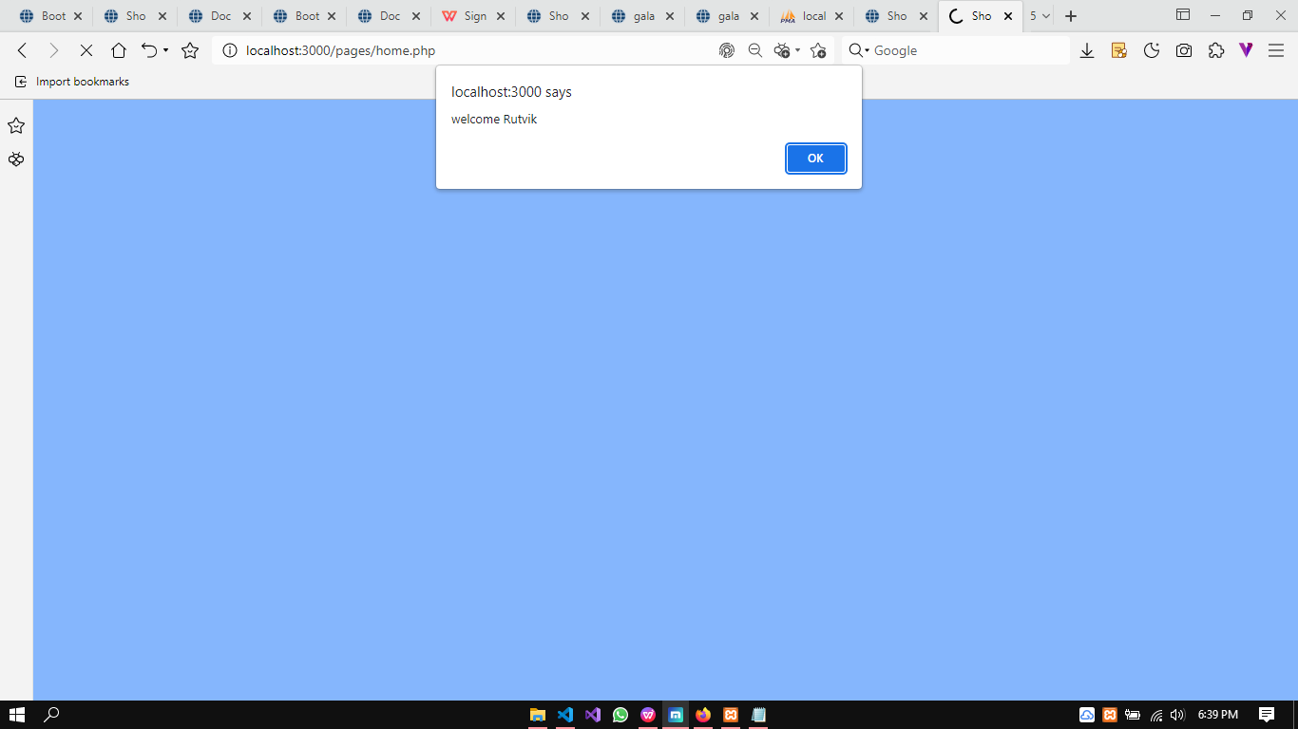

**c. Store details like password, time of login and url in the cookies.**

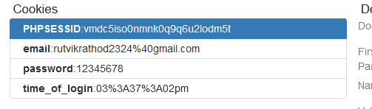

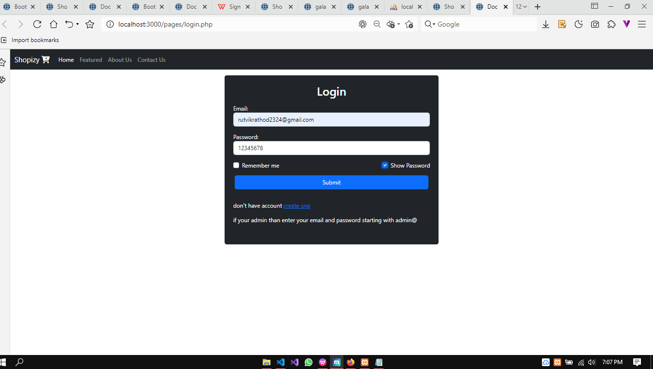

**Code snippet:**

<?php

session_start();

$logged=false;

$email_err=$pass_err="";

if($_SERVER["REQUEST_METHOD"]=="POST")

{

//VALIDATING EMAIL

if(empty($_POST['email']))

{

$email_err="Enter Email";

}

else if(!filter_var($_POST['email'],FILTER_VALIDATE_EMAIL)){

$email_err='Enter Valid Email';

}

//VALIDATING PASSWORD

if(empty($_POST['pswd']))

{

$pass_err='Enter Password';

}

else if(strlen($_POST['pswd'])<8)

{

$pass_err='password should be atleast 8 length';

}

if(empty($pass_err)&&empty($email_err))

{

$_SESSION['email']=$_POST['email'];

$_SESSION['password']=md5($_POST['pswd']);

setcookie('email',$_POST['email'],time()+2*24*60*60);

setcookie('password',$_POST['pswd'],time()+2*24*60*60);

setcookie('time_of_login',date('h:i:sa'),time()+2*24*60*60);

header("location:home.php");

}

else {

header("location:login.php");

}

}

?>

<!DOCTYPE html>

<html lang="en">

<head>

<meta charset="UTF-8">

<meta name="viewport" content="width=device-width, initial-scale=1.0">

<link href="https://cdn.jsdelivr.net/npm/bootstrap@5.2.3/dist/css/bootstrap.min.css" rel="stylesheet">

<script src="https://cdn.jsdelivr.net/npm/bootstrap@5.2.3/dist/js/bootstrap.bundle.min.js"></script>

<link rel="stylesheet" href="https://cdnjs.cloudflare.com/ajax/libs/font-awesome/6.3.0/css/all.min.css">

<title>Document</title>

<style>

.error{

color:red;

}

</style>

</head>

<body>

<!--navbar start-->

<nav class="navbar navbar-expand-lg navbar-dark bg-dark text-white">

<div class="container-fluid">

<a class="navbar-brand" href="#">Shopizy&nbsp;<i class="fa-sharp fa-solid fa-cart-plus"></i></a>

<button class="navbar-toggler" type="button" data-bs-toggle="collapse" data-bs-target="#navbarScroll" aria-controls="navbarScroll" aria-expanded="false" aria-label="Toggle navigation">

<span class="navbar-toggler-icon"></span>

</button>

<div class="collapse navbar-collapse" id="navbarScroll">

<ul class="navbar-nav me-auto my-2 my-lg-0 navbar-nav-scroll" style="--bs-scroll-height: 100px;">

<li class="nav-item">

<a class="nav-link active" aria-current="page" href="#">Home</a>

</li>

<li class="nav-item">

<a class="nav-link" aria-current="page" href="featured.html">Featured</a>

</li>

<li class="nav-item">

<a class="nav-link " area-curren="page" href="about.html">About Us</a>

</li>

<li class="nav-item">

<a class="nav-link " area-curren="page" href="contact.html">Contact Us</a>

</li>

</ul>

</div>

</div>

</nav>

<!--navbar over-->

<!--login form model-->

<div class="container bg-dark mt-3 p-4 rounded text-white col-4">

<h2 class="text-center">Login</h2>

<form action="" method="post" id="loginform">

<div class="mb-3 mt-3">

<label for="email">Email:</label>

<input type="email" class="form-control" id="email" placeholder="Enter Email" name="email">

<span class="error"><?php echo $email_err?></span>

</div>

<div class="mb-3">

<label for="pwd">Password:</label>

<input type="password" class="form-control" id="pwd" placeholder="Enter password" name="pswd">

<span class="error"><?php echo $pass_err?></span>

</div>

<div class="form-check mb-3 d-flex justify-content-between">

<label class="form-check-label me-5">

<input onclick="setCookie()" class="form-check-input" id="rem" type="checkbox" name="remember"> Remember me

</label>

<label class="form-check-label">

<input onclick="showPass()" name="spass" class="form-check-input" type="checkbox" id="showp"> Show Password

</label>

</div>

<div class="row mb-3 mt-3 mx-1">

<input type="submit" name="login" class="btn btn-primary">

</div>

<div class="py-3">

<p id="createac">don't have account <a href="signup.php">create one</a></p>

<p>if your admin than enter your email and password starting with admin@</p>

</div>

</form>

</div

<!-- JS CODE -->

<script>

function showPass()

{

let pswinput=document.getElementById('pwd');

let ckbx=document.getElementById('showp');

if(ckbx.checked==true)

{

pswinput.type='text';

}

else{

pswinput.type='password';

}

}

</script>

</body>

</html>